**GUIA DE APRENDIZAJE UNIDAD 3 N° DE GUÍA: ___19__**

**RECURSO: TEXTO DE ESTUDIO** PAGINAS: Power point

ASIGNATURA: English

NOMBRE ESTUDIANTE: ____________________________CURSO: _7°_ LETRA: ______ FECHA: __________________

|  |
| --- |
| O.A: Demostrar comprensión de ideas generales e información explícita en textos adaptados y auténticos simples, en formato impreso o digital, acerca de temas variados (como experiencias personales, temas de otras asignaturas, del contexto inmediato, de actualidad e interés global o de otras culturas) y que contienen las funciones del año. |
| O.A: Aplicar vocabulario relacionado a sport and free time activities. |
| HABILIDAD: Reading and writing |

1. Fill the gaps writing the sport or activities according to each image.

|  |
| --- |
| A) Cricket B) Figure skating C) Swimming D) Go dancing E) Go camping F) Badminton G) Playing video games H) Collecting |

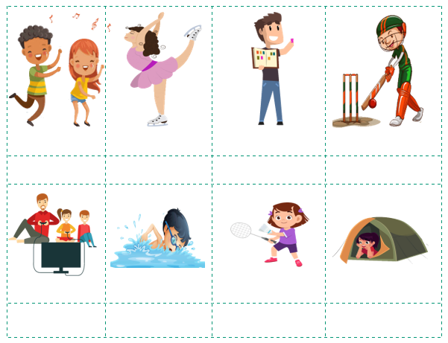

1. According to the previous activity, classify all the activities and sports.

|  |  |  |  |  |
| --- | --- | --- | --- | --- |
| sports and activities | outdoor activity | team sport | individual sport | indoor activity |
| Cricket | ✓ | ✓ |  |  |
| Figure skating |  |  |  |  |
| Swimming |  |  |  |  |
| Go dancing |  |  |  |  |
| Go camping |  |  |  |  |
| Badminton |  |  |  |  |
| Playing video games |  |  |  |  |
| Collecting |  |  |  |  |