**GUIA DE APRENDIZAJE UNIDAD 3 N° DE GUÍA: 19**

**RECURSO: TEXTO DE ESTUDIO** PAGINAS: ______________________

ASIGNATURA: INGLÉS

NOMBRE ESTUDIANTE: ______________________________________________________

curso: segundos letra: a - b – c fecha: __________________

OA13: Escribir (por ejemplo: copiar o completar) palabras y oraciones de acuerdo a un modelo. Identificar ocupaciones y lugares de trabajo.

**MATCH THE PEOPLE WITH THE PLACE WHERE THEY WORK. UNE A LAS PERSONAS CON EL LUGAR EN EL CUAL TRABAJAN.**

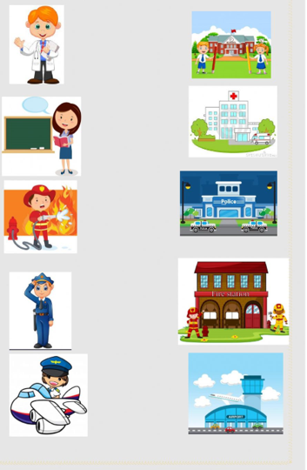

**COMPLETE WITH THE WORDS IN THE BOX. Completa con las palabras en el cuadro**

**GARAGE-HOSPITAL-SCHOOL-POLICE STATION-RESTAURANT-AIRPORT**

**FIRE STATION-STADIUM-BUS**

1. **The doctor works in the _____________________**
2. **The teacher works in the ____________________**
3. **The bus driver works in the ___________________**
4. **The football player works in the _______________________**
5. **The police officer works in the ________________________**
6. **The firefighter works in the __________________________**
7. **The mechanic works in the _________________________**
8. **The chef works in the ______________________________**
9. **The pilot works in the ____________________________**