**GUIA DE APRENDIZAJE UNIDAD 1 N° DE GUÍA: ___13__**

**RECURSO: TEXTO DE ESTUDIO** PAGINAS: Power point

ASIGNATURA: English

NOMBRE ESTUDIANTE: ____________________CURSO: _5°_ LETRA: ______ FECHA: __________________

O.A: Identificar las rutinas diarias aplicando la escritura y la lectura de éstas.

1. Write below every picture the name of the daily routine

Take a shower- play with friends- have lunch- watch TV- do my homework - brush my teeth- go to school- wake up- go to bed

|  |  |  |
| --- | --- | --- |
|  | Boy take a shower | Premium Vector | Play With Friends Cartoon |
|  |  |  |
| Girl Having Lunch On Table Illustration Royalty Free Cliparts ... | Arton Do My Homework Image Provided - EpiCentro Festival | Imágenes, fotos de stock y vectores sobre Vector Watching Tv ... |
|  |  |  |
| Kids go to school vector illustration | Premium Vector | Go To Bed drawing free image | Happy cute little kid girl wake up in the morning | Premium Vector |
|  |  |  |

1. Fill the sentences using daily routines

Take a shower – brush my teeth- do my homework- play with friends- watch T.V- go to bed- have breakfast-

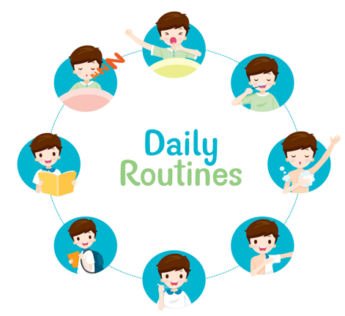

1. I _____________________ every morning to start my day
2. You should ________________________ after every meal
3. I __________ after school and then I can play or watch T.V
4. I can _______________________ after I do my homework
5. I have _____________ every morning before I go to school
6. I _______________ every night to sleep 8 hours