GUIA DE APRENDIZAJE UNIDAD 1 N° DE GUÍA: ___16__
RECURSO: TEXTO DE ESTUDIO PAGINAS: Power point
ASIGNATURA: English
NOMBRE ESTUDIANTE: ____________________________CURSO: _5°_ LETRA: ______ FECHA: __________________
O.A: Completar y escribir, de acuerdo con un modelo y con apoyo de lenguaje visual, textos no literarios (como postales, minilibros, listas de compras) y textos literarios (como rimas, tiras cómicas) con el propósito de compartir información en torno a los temas del año
O.A: Reconocer e identificar lugares de una ciudad
HABILIDAD: Reading and writing

- Read the sentences and fill the gaps using different places in town:

- I eat popcorn and I watch a movie in the _________________________________
- I save my money and I pay checks in the _________________________________
- I read books and I borrow books ________________________________________
- I like to go there; I see my friends and I learn many things___________________
- You can see many animals and have fun in a ______________________________
- There are sick people and many doctors there ____________________________
- You can go there and buy some medicine ________________________________
- There are many police officers there ____________________________________
- There are nuns and priest there _________________________________________

- Write it down a brief list with three objects for each place

- It´s a ___________ and there are:    a)  b)  c) | 2- It´s a ___________ and there are:    a)  b)  c)
- It´s a ___________ and there are :  a)  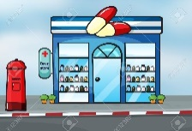  b)  c) | 4- It´s a ____________ and there are :  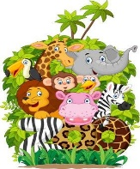  a)  b)  c)

