**GUIA DE APRENDIZAJE UNIDAD 1 N° DE GUÍA: ___1___**

**RECURSO: TEXTO DE ESTUDIO** PAGINAS: ______________________

ASIGNATURA: _______________________________

NOMBRE ESTUDIANTE: ______________________________________________________

CURSO: ___________6°___________________ LETRA: ______ FECHA: __________________

O.A: ____Leer y demostrar comprensión de información explicita en textos adaptados y auténticos simples.

1. 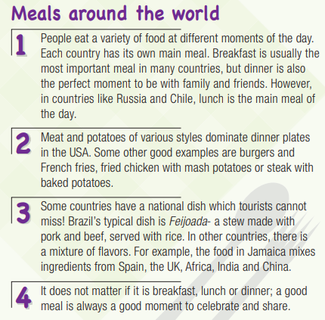Lee con atención y responde tres preguntas relacionadas al texto. Apóyate del diccionario si es necesario.
2. Is lunch the main meal in all countries around the world?
3. What is a good example of meal preparations in the USA?
4. What do you think the phrase “ a mixture of flavors” means?
5. Responde las siguientes preguntas en inglés
6. What is your favorite meal?

________________________________________________

1. What do you like to eat in lunch?

________________________________________________

1. What do you like to drink?

________________________________________________

1. What do you like to eat for dinner?

________________________________________________

1. Do you like fruits?

_______________________________________________

1. Do you like vegetables?

________________________________________________