**GUIA DE APRENDIZAJE UNIDAD 1 N° DE GUÍA: ___13__**

**RECURSO: TEXTO DE ESTUDIO** PAGINAS: Power point

ASIGNATURA: English

NOMBRE ESTUDIANTE: ____________________CURSO: _6°_ LETRA: ______ FECHA: __________________

O.A: Aplicar vocabulario de profesiones y ocupaciones a través de la lectura comprensiva.

1. Read the text and answer T (true) or F (false) according what you read.

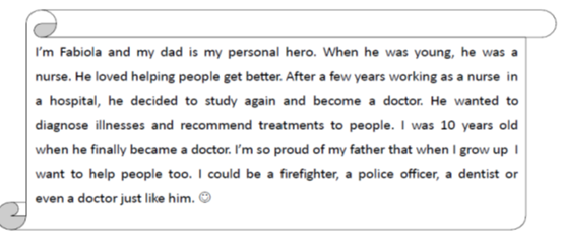



1. _________ Fabiola says that her father is her hero
2. _________ Fabiola´s dad was a nurse before becoming a doctor
3. _________ Fabiola´s dad doesn’t like helping people
4. _________ Fabiola´s was five years old when her dad became a doctor
5. _________ Fabiola is proud of her dad
6. _________ Fabiola doesn´t want to be like her dad at all