**GUIA DE APRENDIZAJE UNIDAD 1 N° DE GUÍA: ___14__**

**RECURSO: TEXTO DE ESTUDIO** PAGINAS: Power point

ASIGNATURA: English

NOMBRE ESTUDIANTE: ____________________CURSO: _6°_ LETRA: ______ FECHA: __________________

O.A: aplicar vocabulario de profesiones y ocupaciones a través de la comprensión lectora y la escritura.

1. Read the text and answer the following questions.

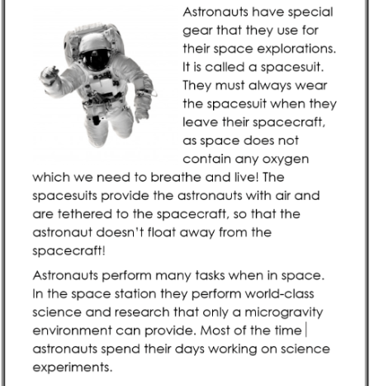

1. What do astronauts wear in the space?

________________________________________________

1. Why do astronauts need to wear that?

________________________________________________

1. What do astronauts spend their days?

________________________________________________

1. Would you like to be an astronaut?

________________________________________________

1. look for 2 famous astronauts who have made significant trips to space

_________________________________________________________

_________________________________________________________

_________________________________________________________

_________________________________________________________

_________________________________________________________

_________________________________________________________

_________________________________________________________

_________________________________________________________

_________________________________________________________

_________________________________________________________

_________________________________________________________

_________________________________________________________

_________________________________________________________

_________________________________________________________

_________________________________________________________

_________________________________________________________

_________________________________________________________

1. choose ten occupations or professions and write a brief description for each

example: Waiter is a person who takes and gives you the order and the food in a restaurant