**GUIA DE APRENDIZAJE UNIDAD 3 N° DE GUÍA: ___20__**

**RECURSO: TEXTO DE ESTUDIO** PAGINAS: Power point

ASIGNATURA: English

NOMBRE ESTUDIANTE: ____________________________CURSO: _7°_ LETRA: ______ FECHA: __________________

|  |
| --- |
| O.A: Leer y demostrar comprensión de textos adaptados y auténticos simples no literarios, que contengan palabras de uso frecuente, familias de palabras, repetición de palabras y frases, estén acompañados de abundante apoyo visual y estén relacionados con los temas y las siguientes funciones del año: saludar y despedirse; solicitar y entregar información personal y de temas familiares; agradecer, disculparse y pedir permiso; seguir y dar instrucciones; describir personas, objetos y su posición, lugares, acciones cotidianas y clima; expresar gustos, preferencias, cantidades y posesiones. |
| O.A: Aplicar vocabulario de deporte y expresiones usando I like. |
| HABILIDAD: Reading and writing |

1. Observe and choose the right name for each object.

|  |
| --- |
| a) gloves b) skates c) bat d) ball e) helmet f) goggles g) net h) racket i) sneakers j) Stick |

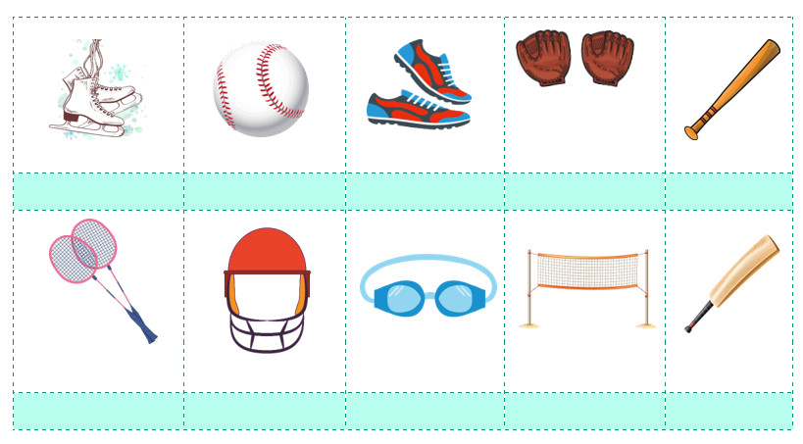

1. Observe the image and match them with the corresponding statement.

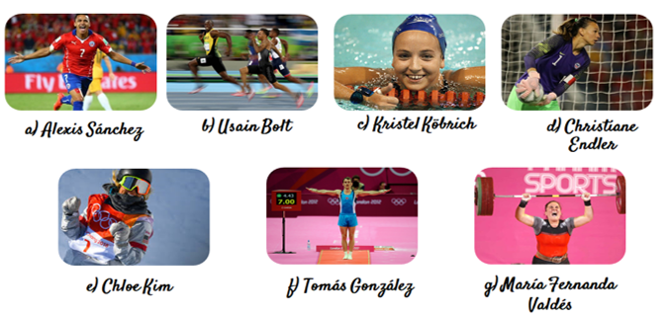

|  |
| --- |
| 1. ___________scored the winning goal at Copa America 2015. 2. ___________She was the first Chilean swimmer to get a medal at Panamerican Games 2003. 3. ___________He finished fourth on the floor and vault finals, at the 2012 Summer Olympics. 4. __________In 2017, the Chilean Olympic committee named her the best sportswoman of the year. 5. _________She was chosen by the French football federation as the best goalkeeper of the season 2018-2019. 6. _________He broke records throughout his whole running career. 7. _______She won an Olympic gold medal at the age of 17. |

1. Fill the gaps using the words in the box according to every sentence.

|  |
| --- |
| Friends - Cooking - Painting - Reading - Listening - Movies Restaurants - Skipping - Playing - Picnic |



* 1. I like ……………….. basketball.
  2. María likes …………. to music.
  3. My Brother loves ………. pictures.
  4. My mom likes ………… in the kitchen.
  5. I love ……………….. comics.
  6. David enjoys watching ..……….
  7. She likes eating in ….…………
  8. Felipe is playing with his ……………..
  9. She enjoys …………..with a rope.
  10. They love having a ……… in the park