**GUIA DE APRENDIZAJE UNIDAD 1 N° DE GUÍA: ___5___**

**RECURSO: TEXTO DE ESTUDIO** PAGINAS: ______________________

ASIGNATURA: INGLÉS

NOMBRE ESTUDIANTE: ____________________CURSO: _8°_básico _ LETRA: ______ FECHA: __________________

O.A: Practice and apply frequency adverbs in a text.

**Unit 1**: Information and communication technologies

Pondremos en practica lo aprendido de adverbios de frecuencia y wh-questions con el fin de reforzar la última clase

**¿Qué haremos a continuación?**

1. Write one or two things you do in your quarantine life, you can use verbs , ex: read, study,eat,etc
2. Tell me something you always do ______________________________
3. Tell me something you sometimes do ___________________________
4. Tell me something you never do _______________________________
5. Read the text and underline the frequency adverbs, then named two things that Bart always does .

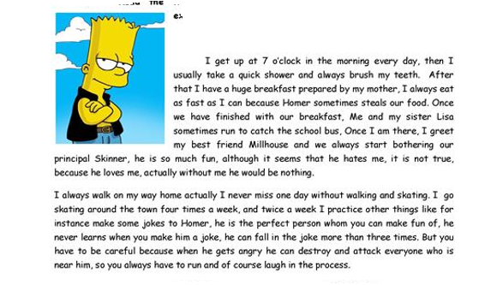

Always: _______________

______________________

______________________

______________________

_______________________

1. Answer the questions using the following frequency adverbs: always, usually,sometimes and never
2. How often do you read a book? ________________________________



1. How often do you do your homework? ___________________________
2. How often do you do exercises? _______________________________



1. How often do you go to the cinema? ____________________________



1. Remember the wh- questions to answer the following questions
2. What´s your name? ___________________
3. How old are you? ____________________
4. Where do you live? ____________________
5. Who do you live with? ___________________
6. Who is your favorite subject? __________________
7. When do you study English? _____________________
8. How old is your best friend? _____________________