**GUIA DE APRENDIZAJE UNIDAD 1 N° DE GUÍA: ___13__**

**RECURSO: TEXTO DE ESTUDIO** PAGINAS: Power point

ASIGNATURA: English

NOMBRE ESTUDIANTE: ____________________CURSO: _8°_ LETRA: ______ FECHA: __________________

O.A: Demostrar conocimiento sobre lugares turísticos a través de la comprensión lectora.

1. 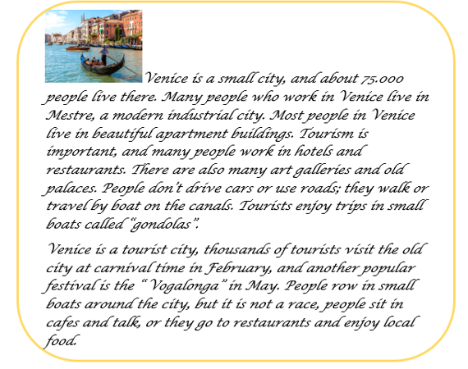Read the text and answer T (true) or F ( false ) according what you read.
2. ___________ Venice is a big city
3. ___________ There are five thousand people living in Venice
4. ___________ Many people work in hotels and restaurants
5. ___________ People drive cars and bicycle there
6. ___________ Tourists don’t like make trips in “gondolas “
7. ___________ There are carnivals and festivals in Venice
8. ___________ Venice is not a tourist city