**GUIA DE APRENDIZAJE UNIDAD 1 N° DE GUÍA: ___14__**

**RECURSO: TEXTO DE ESTUDIO** PAGINAS: Power point

ASIGNATURA: English

NOMBRE ESTUDIANTE: ____________________CURSO: _8°_ LETRA: ______ FECHA: __________________

O.A: Identificar adjetivos calificativos y comparativos con una o más silabas.



1. Make a list with 15 adjectives

1. ________________
2. ________________
3. ________________
4. ________________
5. 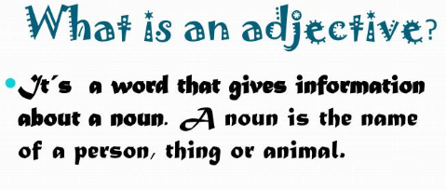 ________________
6. ________________
7. _______________
8. ________________
9. ________________
10. ________________
11. ________________
12. ________________
13. ________________
14. ________________
15. ________________
16. Complete the sentences using the adjective in bracket and applying the comparative form.
17. Kim is ___________ than Mike (tall)
18. Oranges are _______ than pineapples (sweet)
19. Titanic’s movie is ______ than “Siempre el mismo día” (sad)
20. Summer is _______ than spring (hot)
21. My bag is _________ than your bag (heavy)
22. Mike’s shorts are ________ than my shorts (short)
23. Winter is __________ than autumn (cold)
24. Tomas can run _______ than Carlos (fast)
25. Elephants are _______ than a cat (big)
26. Read books is _____________ than play videogames (interesting)